Test Case: tc001_SPX_Dev5_Crear_Nueva_Linea_Requisicion_Spot_Tipo_Cobro_CC
Step 1 - Enter username and password and click to button Enter : Credentials Entered
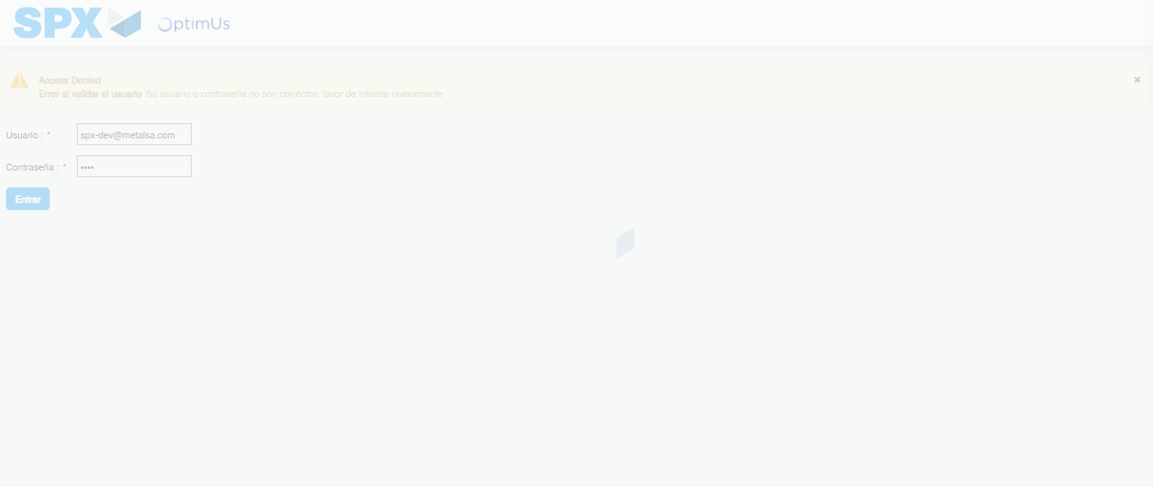Image file-name: QC_Testing-tc001_SPX_Dev5_Crear_Nueva_Linea_Requisicion_Spot_Tipo_Cobro_CC-1790176871792

Step 2 - Select to UEN and Access to Spot Buy Requisitions : UEN Correctly selected and Correct access
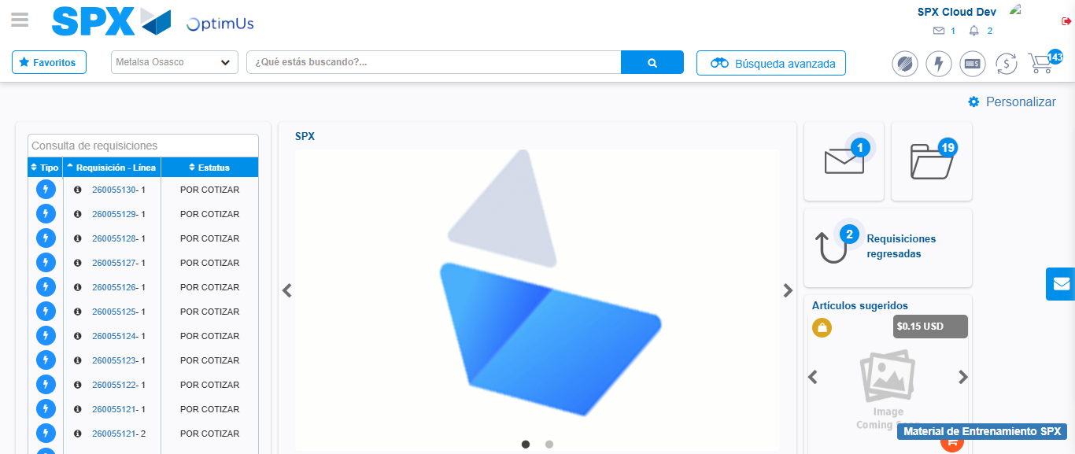Image file-name: QC_Testing-tc001_SPX_Dev5_Crear_Nueva_Linea_Requisicion_Spot_Tipo_Cobro_CC-1790176895293

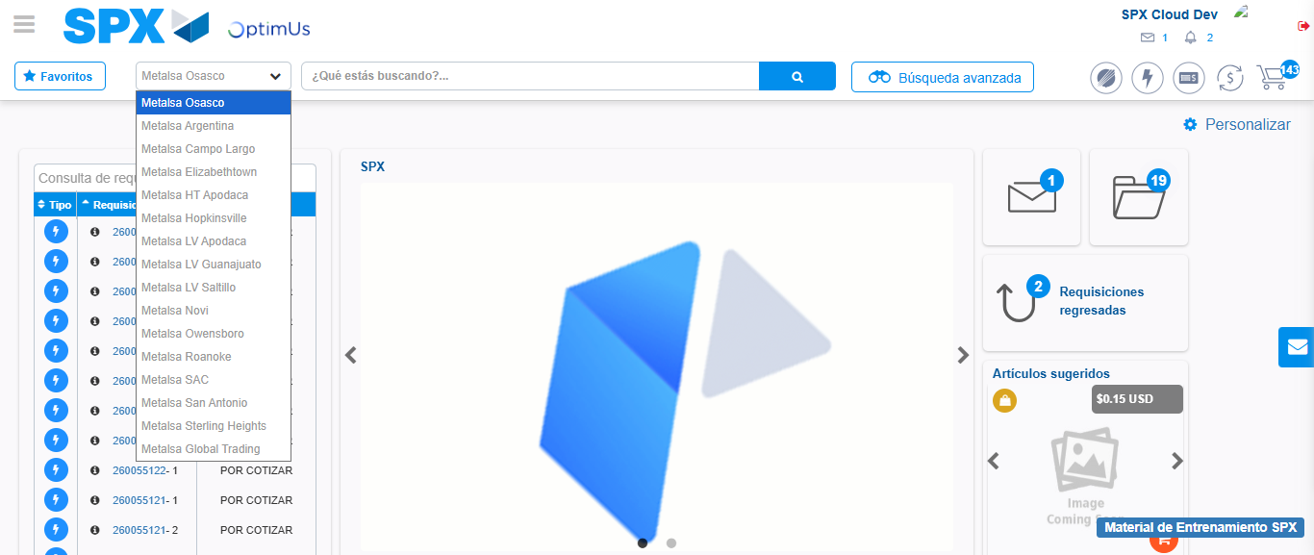Image file-name: QC_Testing-tc001_SPX_Dev5_Crear_Nueva_Linea_Requisicion_Spot_Tipo_Cobro_CC-1790176895790

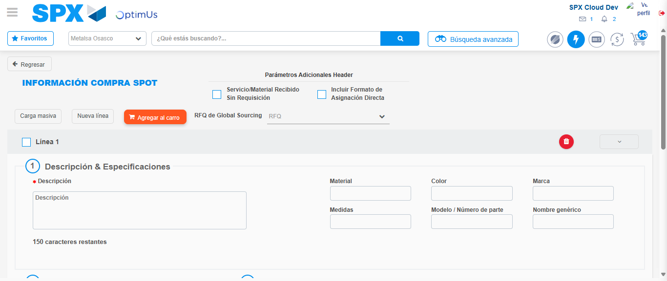Image file-name: QC_Testing-tc001_SPX_Dev5_Crear_Nueva_Linea_Requisicion_Spot_Tipo_Cobro_CC-1790176902278

Step 3 - Data Capture Spot Buy Requisition: Data captured correctly
Image file-name: QC_Testing-tc001_SPX_Dev5_Crear_Nueva_Linea_Requisicion_Spot_Tipo_Cobro_CC-1790176902484

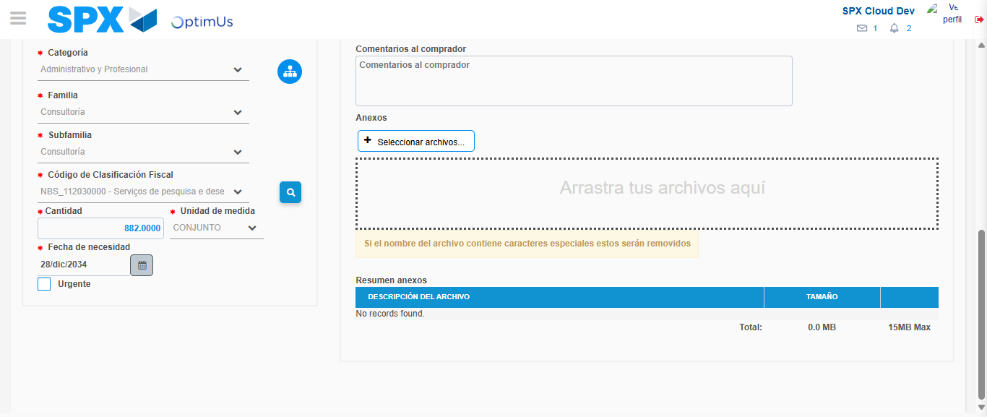Image file-name: QC_Testing-tc001_SPX_Dev5_Crear_Nueva_Linea_Requisicion_Spot_Tipo_Cobro_CC-1790176918158

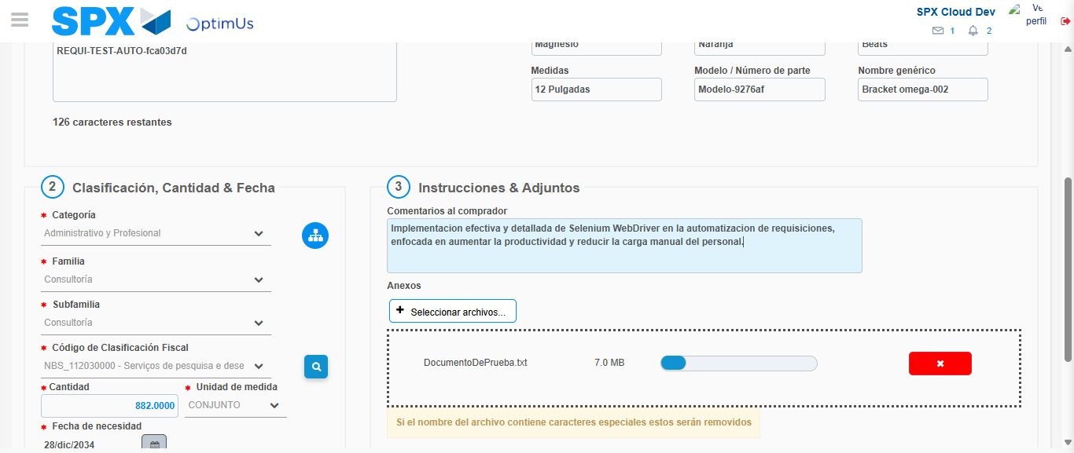Image file-name: QC_Testing-tc001_SPX_Dev5_Crear_Nueva_Linea_Requisicion_Spot_Tipo_Cobro_CC-1790176918869

Step 4 - Add new line and data capture second line: Line add correctly
Image file-name: QC_Testing-tc001_SPX_Dev5_Crear_Nueva_Linea_Requisicion_Spot_Tipo_Cobro_CC-1790176902484

Image file-name: QC_Testing-tc001_SPX_Dev5_Crear_Nueva_Linea_Requisicion_Spot_Tipo_Cobro_CC-1790176918158

Image file-name: QC_Testing-tc001_SPX_Dev5_Crear_Nueva_Linea_Requisicion_Spot_Tipo_Cobro_CC-1790176918869

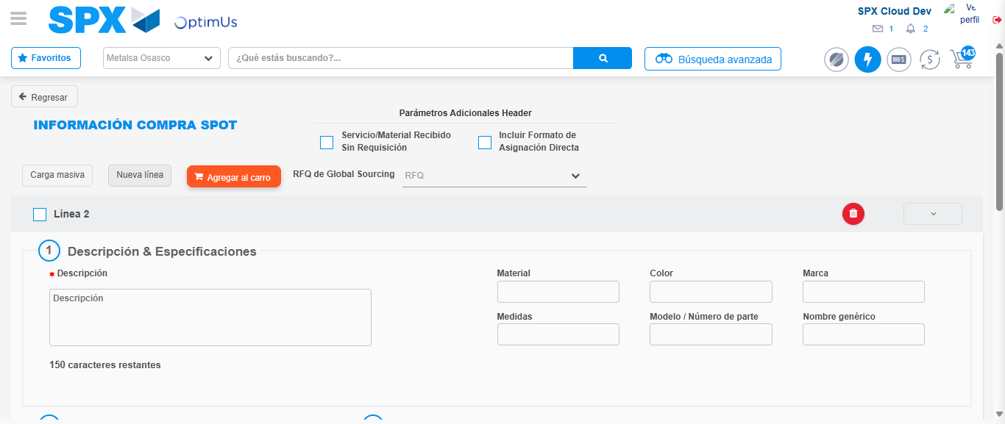Image file-name: QC_Testing-tc001_SPX_Dev5_Crear_Nueva_Linea_Requisicion_Spot_Tipo_Cobro_CC-1790176921114

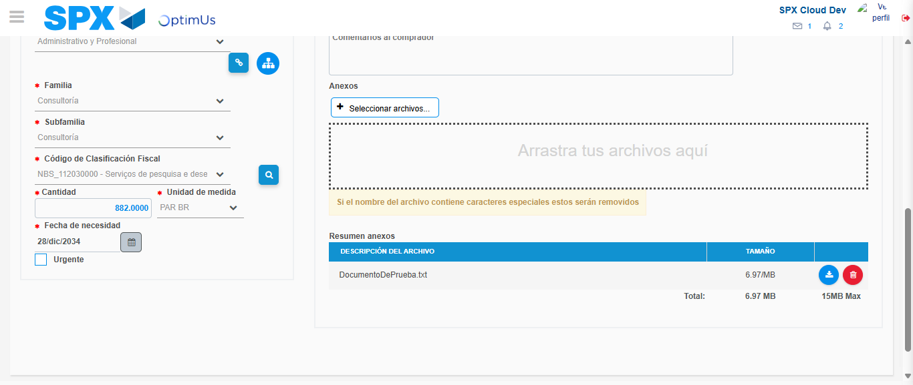Image file-name: QC_Testing-tc001_SPX_Dev5_Crear_Nueva_Linea_Requisicion_Spot_Tipo_Cobro_CC-1790176937129

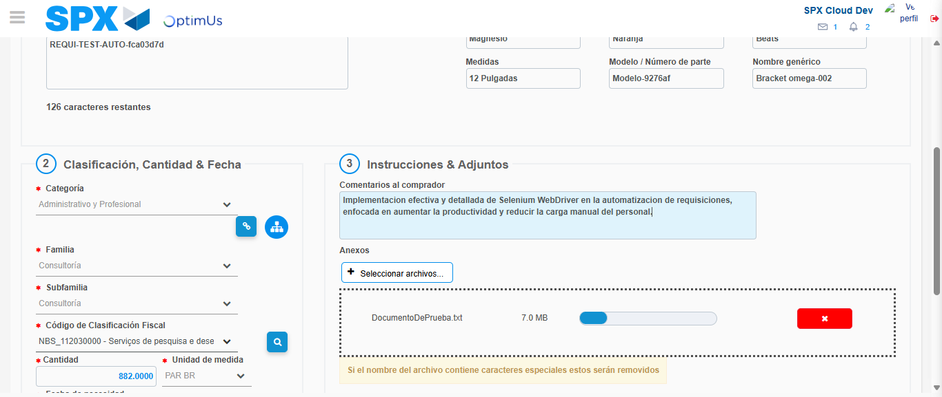Image file-name: QC_Testing-tc001_SPX_Dev5_Crear_Nueva_Linea_Requisicion_Spot_Tipo_Cobro_CC-1790176937846

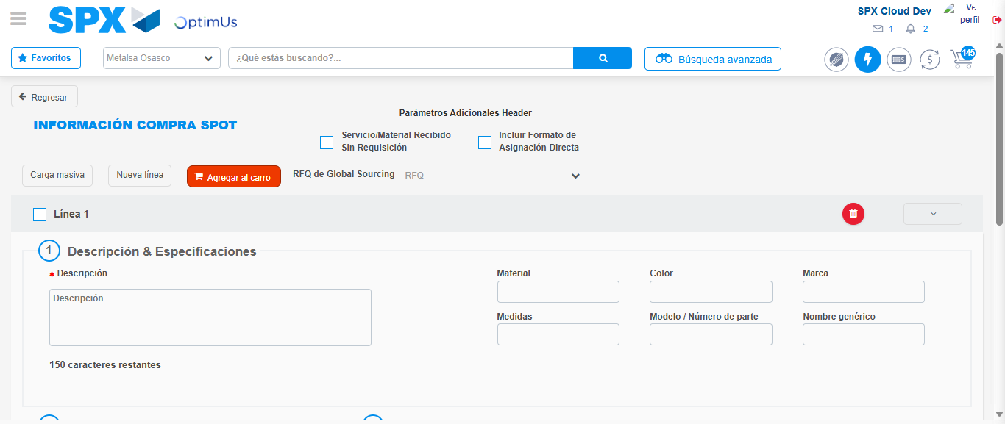Image file-name: QC_Testing-tc001_SPX_Dev5_Crear_Nueva_Linea_Requisicion_Spot_Tipo_Cobro_CC-1790176953471

Step 8 - Return to Main Page SPX : Return to Main Page SPX
Image file-name: QC_Testing-tc001_SPX_Dev5_Crear_Nueva_Linea_Requisicion_Spot_Tipo_Cobro_CC-1790176895293

Image file-name: QC_Testing-tc001_SPX_Dev5_Crear_Nueva_Linea_Requisicion_Spot_Tipo_Cobro_CC-1790176895790

Image file-name: QC_Testing-tc001_SPX_Dev5_Crear_Nueva_Linea_Requisicion_Spot_Tipo_Cobro_CC-1790176902278

Image file-name: QC_Testing-tc001_SPX_Dev5_Crear_Nueva_Linea_Requisicion_Spot_Tipo_Cobro_CC-1790176955674

Image file-name: QC_Testing-tc001_SPX_Dev5_Crear_Nueva_Linea_Requisicion_Spot_Tipo_Cobro_CC-1790176955823

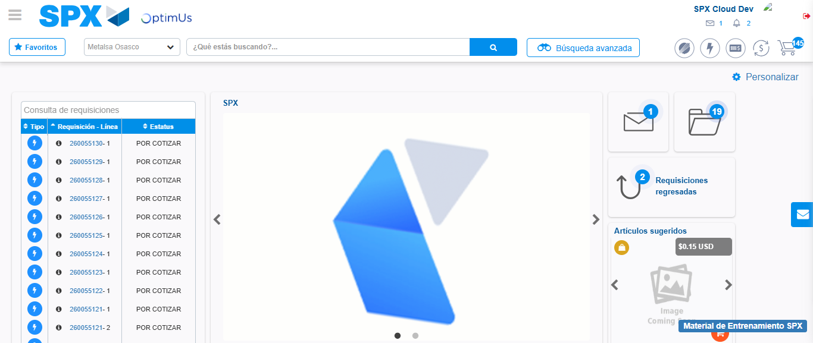Image file-name: QC_Testing-tc001_SPX_Dev5_Crear_Nueva_Linea_Requisicion_Spot_Tipo_Cobro_CC-1790176976839

Step 9 - Log Out : Log Out SPX
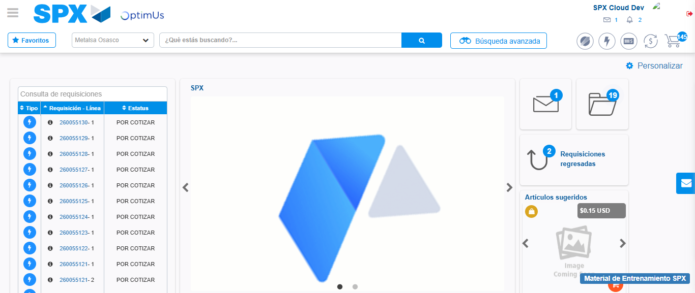Image file-name: QC_Testing-tc001_SPX_Dev5_Crear_Nueva_Linea_Requisicion_Spot_Tipo_Cobro_CC-1790176977110

